### **Program 3 Analysis**

1. Briefly define a *queue* data structure.  
   A queue is a data structure that operates based on first in, first out. Elements are added at one end and come out the other.  
     
   What evidence did you find that a *queue* container was operating in the load balancer?

A queue load balancer just does the tasks in the order that they are received.

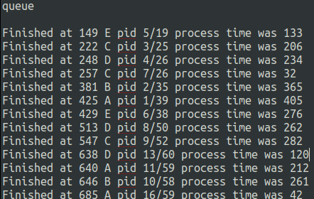for example, the first task to be completed was the shortest one given, which was PID 5, and the first task given, the task with PID of 1 is completed further down, because it took a longer time to do.

1. Briefly define a *stack* data structure.  
   A stack operates based on first in, last out. Element are added and removed from the top of the stack.

What evidence did you find that a *stack* container was operating in the load balancer?

You can tell the load balancer uses a stack, because as you go down the list, the tasks that are being completed are always the newest ones. This is probably not a good container to use because since a stack is first in, last out, some tasks just never get completed and stay at the bottom of the stack--for example, the task with PID 1 was never completed during this run.

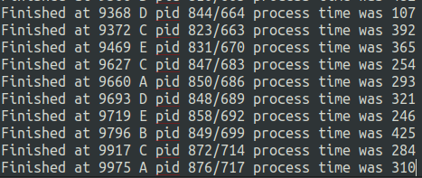

1. Briefly define a *priority queue* data structure.

A priority queue arranges elements based on some definition of priority that they have. Higher priority items go to the front of the queue..

What evidence did you find that a *Max priority queue based on process time* was operating in the load balancer?

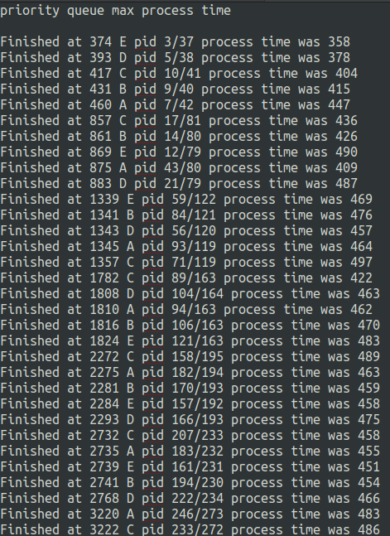You can see that the load balancer using a priority queue based on max processing time always completes tasks that take the longest first. The process time is consistently above 400, in the screenshot.

What evidence did you find that a *Min priority queue based on process time* was operating in the load balancer?

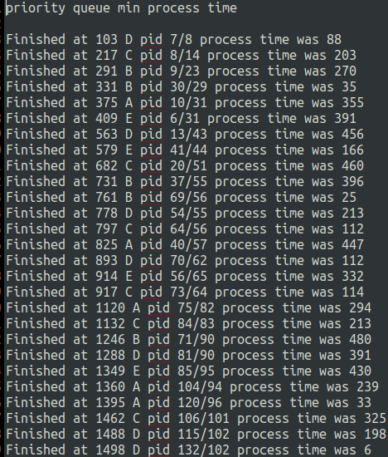For the min priority queue based on process time, you can see that the load balancer is taking care of tasks with small process times as it receives them.

What evidence did you find that a *Max priority queue based on process ID* was operating in the load balancer?

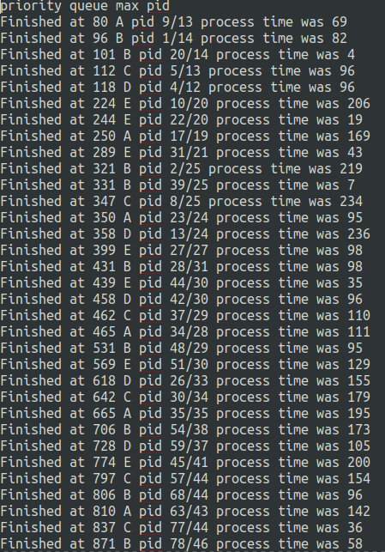For this implementation, it is similar to a normal queue in that tasks are just completed in the order they’re created.